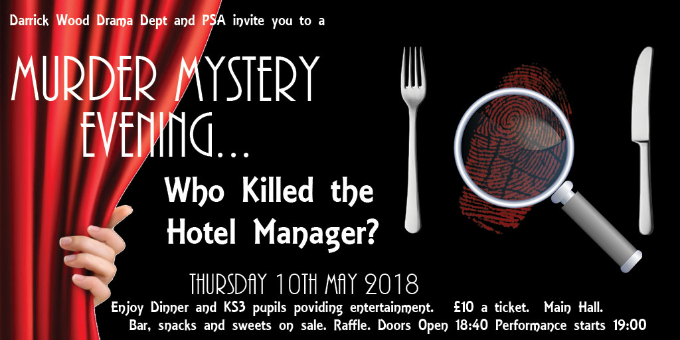

Come along and solve a Murder.
The Drama Dept and the PSA invite you to a Murder Mystery Evening where you the audience attempt to solve the murder…..
Who Killed the Hotel Manager?
Tickets are £10 and you will receive a two course meal:
Main course: Fish and chips or Vegetarian Sausages & Chips
Dessert: Salted Fudge Cheesecake or Lemon Tartlet
This will be a licensed event so you will not permitted to bring your own drinks.
Lager, Ale, Wine and Soft drinks will be on sale. No spirits. Crisps, sweets and chocolate will also be on sale. Small plastic cups will be available – but if you wish to bring your own glasses – particularly for the lager or beer – please feel free to do so.
We will also hold a raffle.
We will make appropriate table arrangements based on the responses. If you wish to sit with friends or family we recommend you buy your tickets using one form.
We will not issue tickets to the production - but we will contact you before the event to confirm details and final arrangements.
DEADLINE FOR TICKETS IS CLOSE OF SCHOOL THURSDAY 3RD MAY IN ORDER THAT WE CAN ORDER FOOD.
If you have any questions regarding the evening please contact info@darrickwoodpsa.co.uk or contact us via the PSA website http://www.darrickwoodpsa.co.uk/contact-us/
Please complete the booking form and return to us by 3rd May 2018
Murder Mystery Evening Booking Form
Please indicate no of tickets required
 |  | No. | Total (£)
No of tickets @ £10 each
Total no. of adults in party
Total no. of children in party
Fish and Chips (meat option)
Vegetarian Sausage & chips (vegetarian option)
Salted Caramel cheesecake
Lemon Tartlet
Name of main contact
Email of main contact
Tel no of main contact
Do you have a child in this production | Yes/No

CHEQUES TO BE MADE PAYABLE TO: DARRICK WOOD PSA
Return form to
PSA box at the school,
or by post:
Darrick Wood PSA, c/o Darrick Wood School, Lovibonds Avenue, Orpington, Kent, BR6 8ER

